WEEK15

Q)Givenanarrayofintegers,reversethegivenarrayinplaceusingan index and loop rather than a built-in function.

# Example

*arr=[1,3,2,4,5]*

Returnthearray*[5,4,2,3, 1]*whichisthereverseoftheinputarray.

# FunctionDescription

Completethefunction*reverseArray* intheeditorbelow.

*reverseArray*hasthefollowingparameter(s):

*intarr[n]*:anarrayofintegers Return

*int[n]*:thearrayinreverseorder

# Constraints

*1≤n≤100*

*0<arr[i]≤100*

# InputFormatForCustomTesting

Thefirstlinecontainsaninteger,*n*,thenumberofelementsin*arr*.

Eachline*i*ofthe*n*subsequentlines(where *0≤i<n*)containsan integer, *arr[i]*.

# SampleCase0

**SampleInputForCustomTesting**

5

1

3

2

4

5

# SampleOutput

5

4

2

3

1

# Explanation

Theinputarrayis[1,3,2,4,5],sothereverseoftheinputarrayis[5,4,2,3,

1].

# SampleCase1

**SampleInputForCustomTesting**

4

17

10

21

45

SampleOutput 45

21

10

17

Explanation

Theinputarrayis[17,10,21,45],sothereverseoftheinputarrayis[45,21,

10,17].

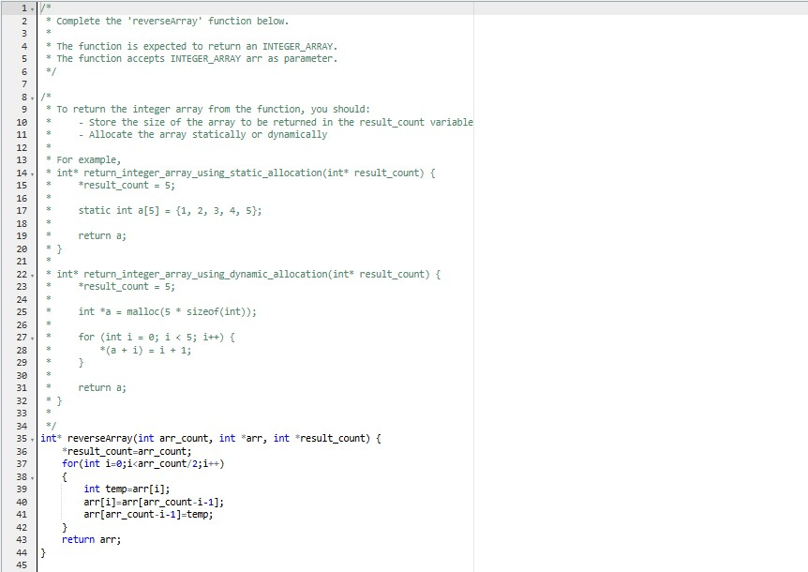

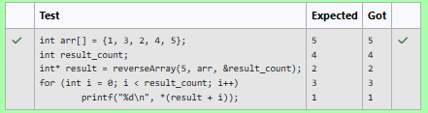

Q) An automated cutting machine is used to cut rods into segments. The cutting machine can only hold a rod of *minLength* or more, and it can only make one cut at a time. Given the array *lengths[]* representing the desired lengths of each segment, determine if it is possible to make the necessary cutsusingthismachine.Therodismarkedintolengthsalready,intheorder given.

# Example

*n=3*

*lengths=[4,3, 2]*

*minLength=7*

The rod is initially *sum(lengths) = 4 + 3 + 2 = 9* units long. First cut off the segment of length *4 + 3 = 7* leaving a rod *9 - 7 = 2*.Then check that the length*7*rodcanbecutintosegments oflengths *4*and *3*.Since*7*is greater than or equal to *minLength = 7*, the final cut can be made.

Return*"Possible"*.

# Example

*n=3*

*lengths=[4,2, 3]*

*minLength=7*

Therodisinitially*sum(lengths)=4+2 +3=9* unitslong.Inthiscase,the initial cut can beof length *4* or *4 + 2 = 6*.Regardless of the length of the firstcut,theremainingpiecewillbeshorterthan*minLength*.Because*n-1*

*=2*cutscannotbemade,theansweris*"Impossible"*.

# FunctionDescription

Completethefunction *cutThemAll*intheeditorbelow.

*cutThemAll*hasthefollowingparameter(s):

*intlengths[n]*:thelengthsofthesegments,inorder

*intminLength*:theminimumlengththemachinecanaccept

Returns

string:*"Possible"*ifall*n-1*cutscanbemade.Otherwise,returnthe string *"Impossible"*.

Constraints

· *2≤n ≤105*

· *1≤t≤109*

* *1≤lengths[i]≤109*
* *Thesumoftheelementsoflengthsequalstheuncutrodlength.*

# InputFormatForCustomTesting

Thefirstlinecontainsaninteger,*n*,thenumberofelementsin*lengths*.

Eachline*i*ofthe*n*subsequentlines(where *0≤i<n*)containsan integer, *lengths[i]*.

Thenextlinecontainsaninteger, *minLength*,theminimumlengthaccepted by the machine.

# SampleCase0

**SampleInputForCustomTesting**

STDIN Function

|  |  |  |
| --- | --- | --- |
| 4 | → | lengths[]sizen=4 |
| 3 | → | lengths[]=[3,5,4,3] |
| 5 |  |  |
| 4 |  |  |
| 3 |  |  |
| 9 | → | minLength=9 |

**SampleOutput** Possible **Explanation**

Theuncutrodis *3+5+4+3=15*unitslong.Cuttherodintolengthsof*3*

*+5+4=12*and*3*.Thencutthe*12*unitpieceintolengths *3*and*5+ 4=9*. The remaining segment is *5 + 4 = 9* units and that is long enough to make the final cut.

# SampleCase1

**SampleInputForCustomTesting**

STDINFunction

3 → lengths[]sizen=3

5 → lengths[]=[5,6,2]

6

2

12 → minLength=12**Sample Output** Impossible

# Explanation

Theuncutrodis *5+6+ 2=13*unitslong.After makingeithercut,therod will be too short to make the second cut.

